|  |  |
| --- | --- |
| C:\Users\e2031043\Pictures\EGC Upward & Onward Logo.jpg | Student Name _________________________    **Eastern Goldfields College**  Mathematics Applications U3&4 2019  Test 2 1– Calculator Free Section |
| **Working Time: 25 minutes** | **No Notes Permitted Total Marks: 30 marks** |

**Question 1 [6 marks: 2, 2, 2]**

For the following sequences determine which are arithmetic, geometric or neither.

Provide a reason to support your answer.

1. 1, 2.5, 4, 5.5, …

1. 5, -5, 5, -5, 5, -5, …
2. 2, 1, 2, 1, 2, 1 …

**Question 2 [11 marks: 3, 3, 3, 2]**

a) A geometric sequence has $T_{3}=4$ and $T_{6}=32$.

i) Determine the recursive rule.

ii) Calculate the 5th term.

b) An arithmetic sequence has $T_{3}=-5$ and $T_{6}=4$.

i) Determine the recursive rule.

ii) Calculate the 5th term.

c) For the following sequence determine the recursive rule and $T_{7}$.

|  |  |  |  |  |
| --- | --- | --- | --- | --- |
| $$T_{1}$$ | $$T_{2}$$ | $$T_{3}$$ | $$T_{4}$$ | $$T_{5}$$ |
| 4 | -8 | 16 | -32 | 64 |

d) The Lucas sequence is defined by  with  and . Determine the first

4 terms in the sequence.

**Question 3 [5 marks: 2, 3]**

The $n$ th term of a sequence is given by the rule $T_{n}= 3^{n-1}+5$

1. Find the first three terms in the sequence.
2. Find the first order recurrence relation that defines the sequence.

**Question 4 [6 marks]**

A sequence is such that T1 = 15, T4 = 30, T5 = 35 and T6 = 40

(i) State a recursive rule for the sequence.

The points ( n, Tn ) are graphed.

(ii) State the shape of the graph.

(iii) State the gradient of the graph.

(iv) State the Tn intercept of the graph.

(v) State the equation of the graph.

**Question 5 [2 marks]**

Match each of the following recursive rules with their respective graph.

1. b) c)

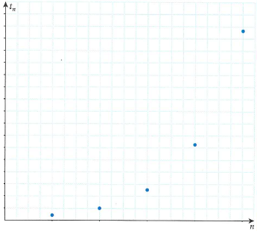

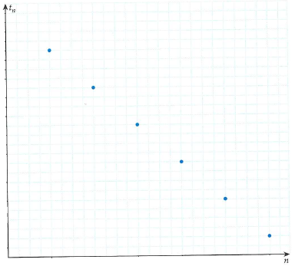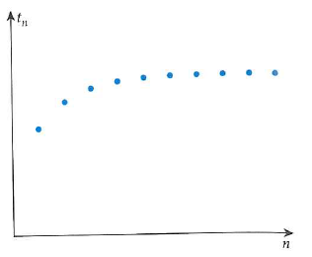



|  |  |  |
| --- | --- | --- |
| C:\Users\e2031043\Pictures\EGC Upward & Onward Logo.jpg | Student Name _______________________    **Eastern Goldfields College**  Mathematics Applications U3&4 2019  Test 2 1– Calculator Assumed Section | |
| **Working Time: 30 minutes** | **A4 Page of Notes Permitted** | **Total Marks: 31 marks** |

**Question 6 [9 marks – 3, 3, 3]**

The first and second terms of a sequence are 2 and 6 respectively.

(a) If these terms form part of a geometric sequence

(i) list the next two terms,

(ii) state a recursive rule for the sequence.

(b) If the two terms form part of an arithmetic sequence, find

(i) the fifth term of the sequence,

(ii) which term of the sequence is the first to exceed 100.

(c) If the recursive rule for the sequence is given by , find

(i) ,

(ii) the smallest value of , , for which .

**Question 7 [7 marks – 1, 2, 2, 2]**

Elsa is negotiating with her mother as to how much pocket money she will get. Elsa suggests starting with $50 in the first month and increasing this by $5 every month.

a) With this scheme, how much pocket money will Elsa receive 12 months from the start?

Elsa’s mother says that increasing the amount by 5% each month is better for Elsa **in the long run**.

b) Use the table below to show how much pocket money Elsa will receive with her scheme and her mother’s scheme for the first 5 months of the year.

|  |  |  |  |  |  |
| --- | --- | --- | --- | --- | --- |
|  | Month 1 | Month 2 | Month 3 | Month 4 | Month 5 |
| Elsa’s scheme |  |  |  |  |  |
| Mother’s scheme |  |  |  |  |  |

c) Is Elsa’s mother correct? Justify your solution mathematically.

d) If the amount of pocket money Elsa will be paid is capped to a maximum of $120/month, does this effect which scheme is better? Justify your solution.



**Question 8 [5 marks – 2, 2, 1]**

A ladder has 21 rungs and from the bottom to the top each rung is shorter than the one before it by a constant amount. The bottom rung is 400 mm long and the top rung is 320 mm.

a) How much shorter is each rung than the rung below it?

b) Give a recursive rule for calculating the length (*Tn*) of the *n*th rung from the rung below it.

c) Give a non-recursive formula for calculating the length of any rung.

**Question 9 [6 marks: 3, 1, 2]**

A commercial fish farming operation has approximately 10,000 fish in one of its artificial lakes. It is thought that without any intervention this population will continue to increase at the rate of 1.5% per week.

However, intervention is planned that will see 200 fish harvested from the lake at the end of each week, the first harvest will be one week from now.

1. Give the first order linear recurrence relation for this sequence.

b) How many weeks does it take for the number of fish in the lake to fall below 8000?

b) Describe what happens to the fish farming operation in the long term.

**Question 10 [4 marks: 3, 1]**

The numbers 5, *x* and 49 are the first three terms of the sequence defined by the first order recurrence relation $T_{n+1}= rT_{n}+1; T_{1}=5$

1. Find the values of *r* and *x*, given that *x* > 0.
2. Find the fourth term in the sequence.

**END OF TEST**